Basics of Cisco Packet Tracer Pt2 – Hubs

Hub –

* A hub is also called as a Network Hub.
* It works in the Physical layer of the OSI model.
* It is used to set up LAN.
* Hub has multiple ports.
* The usage of hubs comes under Sar Topology.
* When a data packet arrives at one of the numerous ports in hub, it is copied to the remaining ports of the hub so that all the segments in LAN can see the packets. This improves scalability in the Network Communication.
* A hub can be connected to another hub via one port; if all other ports are busy.

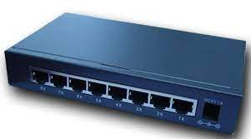

Working of a HUB –

When a data packet is received on one port, other port also receives the copies of the data whether required or not. This type of data transfer is less secure. Hence Hubs have a major drawback in Network Communication.

Pros and Cons of HUBS –

Pros –

1. Cheaper than Switches.
2. Works good for smaller networks.

Cons –

1. Issues with Broadcasting. (use of multiple devices like 100,1000,etc)
2. No memory.
3. Normally runs in Half Duplex mode. (1 direction of data flow at a time)